Day 01

Data Analytics Fundamentals
Introduction to Data Analytics & Data Science

1. What is Data?
Data is any collection of raw facts, figures, or observations — numbers, text, images, sounds, or measurements — that on its own carries no inherent meaning. It becomes useful only after it is processed, organized, and interpreted. Data can be generated by people (surveys, transactions, social media) or by machines (sensors, logs, IoT devices).

2. Definition of Data Analytics
Data Analytics is the process of examining raw data to uncover patterns, correlations, and trends that support decision-making. It focuses on answering specific business questions using statistical methods, data visualization, and reporting tools, typically working with historical and current data to explain what happened and why.

3. Definition of Data Science
Data Science is a broader, multidisciplinary field that combines statistics, mathematics, programming, and domain knowledge to extract insights and build predictive models from structured and unstructured data. It encompasses the entire data lifecycle — from data collection and cleaning to machine learning, model deployment, and communicating results — with an emphasis on predicting future outcomes, not just explaining past ones.

4. Data Analyst vs Data Scientist
Aspect | Data Analyst | Data Scientist
Primary focus | Interpreting existing data to answer specific questions | Building models to predict future outcomes
Core skills | SQL, Excel, visualization tools (Power BI, Tableau) | Python/R, machine learning, statistics, big data tools
Output | Dashboards, reports, business insights | Predictive models, algorithms, data products
Data type | Mostly structured data | Structured and unstructured data
Approach | Descriptive & diagnostic analysis | Predictive & prescriptive modeling

5. Data Engineer vs ML Engineer
Aspect | Data Engineer | ML Engineer
Primary focus | Building and maintaining data pipelines and infrastructure | Designing, training, and deploying machine learning models
Core skills | ETL pipelines, databases, Spark, cloud platforms | Python, ML frameworks (TensorFlow/PyTorch), MLOps
Output | Clean, reliable, well-structured data pipelines | Production-ready, scalable ML models
Works closely with | Data analysts and data scientists | Data scientists and software engineers

6. Structured vs Unstructured Data
Aspect | Structured Data | Unstructured Data
Format | Organized in rows and columns (tabular) | No predefined format or model
Storage | Relational databases (SQL) | NoSQL databases, data lakes, file storage
Examples | Spreadsheets, sales records, sensor readings | Emails, images, videos, social media posts, PDFs
Ease of analysis | Easy to search and analyze directly | Requires processing (NLP, computer vision) before analysis

7. Types of Analytics
- Descriptive Analytics — summarizes historical data to answer "What happened?" using reports, dashboards, and summary statistics.
- Diagnostic Analytics — digs deeper into data to answer "Why did it happen?" through drill-down, correlation, and root-cause analysis.
- Predictive Analytics — uses statistical models and machine learning to answer "What is likely to happen?" based on historical patterns.
- Prescriptive Analytics — recommends specific actions to answer "What should we do?", often using optimization and simulation techniques.

8. Data Science / Data Project Lifecycle
A typical data project moves through a structured workflow, starting from identifying a real business problem and ending with a deployed solution that drives a decision:
Business Problem
↓
Data Collection
↓
Data Cleaning
↓
Data Exploration
↓
Statistical Analysis
↓
Visualization
↓
Machine Learning
↓
Model Evaluation
↓
Business Decision
↓
Deployment / Reporting

9. Real-World Examples
- E-commerce (Amazon, Flipkart) — recommendation engines suggest products based on browsing and purchase history (predictive analytics).
- Banking & Finance — credit scoring models and fraud-detection systems flag suspicious transactions in real time.
- Healthcare — predictive models forecast disease risk and optimize hospital resource allocation.
- Agriculture — data on soil, weather, and crop yield helps farmers decide the best time to sow, irrigate, and harvest.
- Retail — sales dashboards (descriptive analytics) help store managers track daily performance and inventory levels.

10. Technologies Used by Data Analysts
- Excel and Google Sheets for quick calculations and reporting
- SQL for querying and managing relational databases
- Power BI and Tableau for building interactive dashboards
- Python or R (basic level) for statistical analysis

11. Technologies Used by Data Scientists
- Python (Pandas, NumPy, Scikit-learn) and R for analysis and modeling
- Machine learning frameworks: TensorFlow, PyTorch, Keras
- Big data tools: Apache Spark, Hadoop
- Cloud platforms: AWS, Google Cloud, Microsoft Azure
- Version control and deployment: Git, Docker, MLflow

Why This Matters
Before learning specific tools, it is essential to understand where those tools are actually applied. Knowing the difference between analytics and science, and seeing the full project lifecycle, gives context for every technique learned afterward — each tool exists to solve a step in this larger workflow.

DAY 2 — Python Fundamentals
Task: Learn Python basics
1. Variables
Definition / Theory: Variable is a name used to store a value in Python.
Example:
name = "Indrajit"
age = 22
2. Data Types
Definition / Theory: Data type tells what type of value a variable stores.
Example:
x = 10 # int
name = "Ram" # string
3. Strings
Definition / Theory: String is a collection of characters written inside quotes.
Example:
name = "Indrajit"
print(name)
Output:
Indrajit
4. Integers
Definition / Theory: Integer is a whole number without a decimal point.
Example:
age = 22
5. Float
Definition / Theory: Float is a number that contains a decimal value.
Example:
price = 99.50
6. Boolean
Definition / Theory: Boolean has only two values: True or False.
Example:
is_student = True
7. Lists
Definition / Theory: List is an ordered and changeable collection of values.
Example:
fruits = ["Apple", "Mango", "Banana"]
print(fruits)
8. Tuples
Definition / Theory: Tuple is an ordered collection that cannot be changed after creation.
Example:
numbers = (10, 20, 30)
9. Sets
Definition / Theory: Set is an unordered collection that stores unique values.
Example:
numbers = {10, 20, 30, 10}
print(numbers)
Output:
{10, 20, 30}
10. Dictionaries
Definition / Theory: Dictionary stores data in key-value pairs.
Example:
student = {"name": "Indrajit", "age": 22}
print(student["name"])
Output:
Indrajit
11. Operators
Definition / Theory: Operators are symbols used to perform operations on values.
Example:
a = 10
b = 5
print(a + b)
Output:
15
Common operators: +, -, *, /, %, ==, >, <
12. Conditions
Definition / Theory: Conditions are used to make decisions using if, elif, and else.
Example:
age = 20
if age >= 18:
print("Adult")
else:
print("Minor")
Output:
Adult
13. Loops
Definition / Theory: Loop is used to repeat a block of code multiple times.
Example:
for i in range(1, 4):
print(i)
Output:
1
2
3
Programs with User Input — Theory, Code and Output
1. Calculator
Theory: Calculator performs basic arithmetic operations.
Code:
a = float(input("Enter first number: "))
b = float(input("Enter second number: "))
print("Addition:", a + b)
print("Subtraction:", a - b)
print("Multiplication:", a * b)
print("Division:", a / b)
Output:
Enter first number: 10
Enter second number: 5
Addition: 15.0
Subtraction: 5.0
Multiplication: 50.0
Division: 2.0
2. Even/Odd Number
Theory: An even number is divisible by 2; otherwise it is odd.
Code:
n = int(input("Enter a number: "))
if n % 2 == 0:
print("Even number")
else:
print("Odd number")
Output:
Input: 8
Output: Even number
3. Positive/Negative Number
Theory: A positive number is greater than 0 and a negative number is less than 0.
Code:
n = int(input("Enter a number: "))
if n > 0:
print("Positive number")
elif n < 0:
print("Negative number")
else:
print("Zero")
Output:
Input: -5
Output: Negative number
4. Largest of 3 Numbers
Theory: We compare three numbers to find the greatest value.
Code:
a = int(input("Enter first number: "))
b = int(input("Enter second number: "))
c = int(input("Enter third number: "))
print("Largest:", max(a, b, c))
Output:
Input: 10, 25, 15
Output: Largest: 25
5. Student Grade Calculator
Theory: A grade is assigned according to the student’s marks.
Code:
marks = float(input("Enter marks: "))
if marks >= 90:
print("Grade A")
elif marks >= 75:
print("Grade B")
elif marks >= 60:
print("Grade C")
elif marks >= 40:
print("Grade D")
else:
print("Fail")
Output:
Input: 82
Output: Grade B
6. Multiplication Table
Theory: A for loop is used to print a multiplication table.
Code:
n = int(input("Enter a number: "))
for i in range(1, 11):
print(n, "x", i, "=", n * i)
Output:
Input: 5
5 x 1 = 5
5 x 2 = 10
5 x 3 = 15
5 x 4 = 20
5 x 5 = 25
5 x 6 = 30
5 x 7 = 35
5 x 8 = 40
5 x 9 = 45
5 x 10 = 50
7. Factorial
Theory: Factorial is the product of all positive integers from 1 to the given number.
Code:
n = int(input("Enter a number: "))
fact = 1
for i in range(1, n + 1):
fact = fact * i
print("Factorial:", fact)
Output:
Input: 5
Output: Factorial: 120
8. Fibonacci Series
Theory: In Fibonacci series, each number is the sum of the previous two numbers.
Code:
n = int(input("Enter number of terms: "))
a, b = 0, 1
for i in range(n):
print(a, end=" ")
a, b = b, a + b
Output:
Input: 7
Output: 0 1 1 2 3 5 8
9. Count Vowels
Theory: Vowels are a, e, i, o and u; we count them in the string.
Code:
text = input("Enter a string: ")
count = 0
for ch in text.lower():
if ch in "aeiou":
count += 1
print("Number of vowels:", count)
Output:
Input: python programming
Output: Number of vowels: 4
10. Reverse a String
Theory: A string can be reversed using slicing.
Code:
text = input("Enter a string: ")
print("Reverse:", text[::-1])
Output:
Input: Python
Output: Reverse: nohtyP
Why Important
Python serves as the foundational programming language needed for all subsequent curriculum projects (e.g., data analysis, scraping, or automation). Master these basics to easily build and debug complex code later.
How to Practice
- Manual Logic First: Outline the problem-solving steps on paper or pseudocode before coding to build core algorithmic thinking.
- Test Different Inputs: Run the program with various values and edge cases to ensure the code is reliable and dynamic.

DAY 3 — Functions + Advanced Python Basics
Task: Learn Functions + Advanced Python Basics
1. Functions
Definition / Theory: A function is a reusable block of code that performs a specific task.
Example:
def greet():
print("Hello")
greet()
Output:
Hello
2. Parameters
Definition / Theory: Parameters are values received by a function when it is called.
Example:
def greet(name):
print("Hello", name)
greet("Indrajit")
Output:
Hello Indrajit
3. Return Values
Definition / Theory: A return value is the result sent back from a function using the return statement.
Example:
def add(a, b):
return a + b
result = add(10, 5)
print(result)
Output:
15
4. Lambda
Definition / Theory: A lambda is a small anonymous function written in one line.
Example:
square = lambda x: x * x
print(square(5))
Output:
25
5. map()
Definition / Theory: map() applies a function to every item in an iterable.
Example:
numbers = [1, 2, 3, 4]
result = list(map(lambda x: x * 2, numbers))
print(result)
Output:
[2, 4, 6, 8]
6. filter()
Definition / Theory: filter() selects items that satisfy a condition.
Example:
numbers = [1, 2, 3, 4, 5, 6]
result = list(filter(lambda x: x % 2 == 0, numbers))
print(result)
Output:
[2, 4, 6]
7. List Comprehension
Definition / Theory: List comprehension is a short way to create a list using an expression and loop.
Example:
numbers = [1, 2, 3, 4, 5]
squares = [x * x for x in numbers]
print(squares)
Output:
[1, 4, 9, 16, 25]
8. Dictionary Comprehension
Definition / Theory: Dictionary comprehension is a short way to create a dictionary using an expression and loop.
Example:
numbers = [1, 2, 3]
squares = {x: x * x for x in numbers}
print(squares)
Output:
{1: 1, 2: 4, 3: 9}
9. Exception Handling
Definition / Theory: Exception handling is used to handle runtime errors without stopping the program unexpectedly.
Example:
try:
a = 10
b = 0
print(a / b)
except ZeroDivisionError:
print("Cannot divide by zero")
Output:
Cannot divide by zero
10. Modules
Definition / Theory: A module is a Python file containing reusable code such as functions and variables.
Example:
import math
print(math.sqrt(25))
Output:
5.0
Required Functions
Create these functions: calculate_average(), calculate_max(), calculate_min(), calculate_grade(), calculate_percentage(). Then create one Python program that uses all functions.
Complete Program:
def calculate_average(numbers):
return sum(numbers) / len(numbers)
def calculate_max(numbers):
return max(numbers)
def calculate_min(numbers):
return min(numbers)
def calculate_grade(percentage):
if percentage >= 90:
return "A"
elif percentage >= 75:
return "B"
elif percentage >= 60:
return "C"
elif percentage >= 40:
return "D"
else:
return "Fail"
def calculate_percentage(obtained, total):
return (obtained / total) * 100
marks = [80, 75, 90, 85, 70]
average = calculate_average(marks)
maximum = calculate_max(marks)
minimum = calculate_min(marks)
percentage = calculate_percentage(sum(marks), len(marks) * 100)
grade = calculate_grade(percentage)
print("Marks:", marks)
print("Average:", average)
print("Maximum:", maximum)
print("Minimum:", minimum)
print("Percentage:", percentage)
print("Grade:", grade)
Output:
Marks: [80, 75, 90, 85, 70]
Average: 80.0
Maximum: 90
Minimum: 70
Percentage: 80.0
Grade: B
Why?
Large projects cannot be written as one huge Python script. Functions make code reusable, readable, and maintainable.
Deliverable
Save the completed program as day03_python_functions.py.

DAY 4 — NumPy
Task: Learn NumPy
1. Array
Definition / Theory: An array is a collection of values stored in a NumPy array.
Example / Code:
import numpy as np
arr = np.array([10, 20, 30, 40])
print(arr)
Output:
[10 20 30 40]
2. Dimensions
Definition / Theory: Dimension tells how many axes an array has.
Example / Code:
arr = np.array([10, 20, 30])
print(arr.ndim)
Output:
1
3. Shape
Definition / Theory: Shape tells the size of an array along each dimension.
Example / Code:
arr = np.array([[1, 2, 3], [4, 5, 6]])
print(arr.shape)
Output:
(2, 3)
4. Indexing
Definition / Theory: Indexing is used to access an individual element of an array.
Example / Code:
arr = np.array([10, 20, 30, 40])
print(arr[2])
Output:
30
5. Slicing
Definition / Theory: Slicing is used to select a range of elements from an array.
Example / Code:
arr = np.array([10, 20, 30, 40, 50])
print(arr[1:4])
Output:
[20 30 40]
6. Reshape
Definition / Theory: Reshape changes the dimensions of an array without changing its data.
Example / Code:
arr = np.array([1, 2, 3, 4, 5, 6])
new_arr = arr.reshape(2, 3)
print(new_arr)
Output:
[[1 2 3]
[4 5 6]]
7. Arithmetic Operations
Definition / Theory: NumPy supports element-wise arithmetic operations on arrays.
Example / Code:
a = np.array([10, 20, 30])
b = np.array([1, 2, 3])
print(a + b)
print(a * b)
Output:
[11 22 33]
[10 40 90]
8. Aggregations
Definition / Theory: Aggregation functions calculate summary values such as total, maximum and minimum.
Example / Code:
sales = np.array([100, 200, 300, 400])
print(np.sum(sales))
print(np.max(sales))
print(np.min(sales))
Output:
1000
400
100
9. Mean
Definition / Theory: Mean is the average value of the data.
Example / Code:
sales = np.array([100, 200, 300, 400])
print(np.mean(sales))
Output:
250.0
10. Median
Definition / Theory: Median is the middle value after sorting the data.
Example / Code:
sales = np.array([100, 200, 300, 400, 500])
print(np.median(sales))
Output:
300.0
11. Standard Deviation
Definition / Theory: Standard deviation measures how spread out the values are from the mean.
Example / Code:
sales = np.array([100, 200, 300, 400])
print(np.std(sales))
Output:
111.80339887498948
Sales Data — Complete Task
Create a NumPy array containing sales data and perform Total Sales, Average Sales, Maximum Sales, Minimum Sales, Standard Deviation, Median, 25th Percentile and 75th Percentile.
Code:
import numpy as np
sales = np.array([100, 200, 300, 400, 500])
print("Sales:", sales)
print("Total Sales:", np.sum(sales))
print("Average Sales:", np.mean(sales))
print("Maximum Sales:", np.max(sales))
print("Minimum Sales:", np.min(sales))
print("Standard Deviation:", np.std(sales))
print("Median:", np.median(sales))
print("25th Percentile:", np.percentile(sales, 25))
print("75th Percentile:", np.percentile(sales, 75))
Output:
Sales: [100 200 300 400 500]
Total Sales: 1500
Average Sales: 300.0
Maximum Sales: 500
Minimum Sales: 100
Standard Deviation: 141.4213562373095
Median: 300.0
25th Percentile: 200.0
75th Percentile: 400.0
Practice 1 — 1D Array
Theory: A 1D array contains elements in a single dimension.
arr = np.array([10, 20, 30, 40])
print(arr)
Output:
[10 20 30 40]
Practice 2 — 2D Array
Theory: A 2D array contains rows and columns.
arr = np.array([[1, 2], [3, 4]])
print(arr)
Output:
[[1 2]
[3 4]]
Practice 3 — Matrix Multiplication
Theory: Matrix multiplication multiplies compatible matrices using the dot product rule.
a = np.array([[1, 2], [3, 4]])
b = np.array([[5, 6], [7, 8]])
result = np.matmul(a, b)
print(result)
Output:
[[19 22]
[43 50]]
Practice 4 — Reshaping
Theory: Reshaping changes the array structure while keeping the same number of elements.
arr = np.array([1, 2, 3, 4, 5, 6])
result = arr.reshape(3, 2)
print(result)
Output:
[[1 2]
[3 4]
[5 6]]
Why?
NumPy provides the numerical foundation used by many data-science libraries.
Deliverable
Save the work as Day04_NumPy.ipynb.

DAY 5 — Pandas Basics
Task: Learn Pandas
👉 Pandas = Python library used to read, clean, analyze, and manage data.
Topics: Series, DataFrame, read_csv(), head(), tail(), info(), describe(), shape, columns, dtypes
1. Series
Theory: A Series is a one-dimensional labeled data structure in Pandas. It can store numbers, strings, or other values.
Example:
import pandas as pd
data = pd.Series([10, 20, 30, 40])
print(data)
Output:
0 10
1 20
2 30
3 40
dtype: int64

2. DataFrame
Theory: A DataFrame is a two-dimensional table with rows and columns.
Example:
import pandas as pd

data = {
"Name": ["Indrajit", "Rahul", "Amit"],
"Age": [22, 23, 21]
}

df = pd.DataFrame(data)
print(df)
Output:
Name Age
0 Indrajit 22
1 Rahul 23
2 Amit 21

3. read_csv()
Theory: read_csv() is used to load data from a CSV file into a Pandas DataFrame.
Example:
import pandas as pd

df = pd.read_csv("Beginner_Friendly_Sales_Dataset.csv")
print(df)
Output:
Date Product Quantity Sales
0 2026-01-01 Laptop 2 120000
1 2026-01-02 Mouse 10 5000
2 2026-01-03 Keyboard 7 10500
...

4. head()
Theory: head() displays the first rows of a DataFrame. By default, it displays the first 5 rows.
Example:
print(df.head())
To display the first 10 rows:
print(df.head(10))

5. tail()
Theory: tail() displays the last rows of a DataFrame. By default, it displays the last 5 rows.
Example:
print(df.tail())
To display the last 10 rows:
print(df.tail(10))

6. info()
Theory: info() gives information about the DataFrame, such as number of rows, columns, non-null values, and data types.
Example:
df.info()
Output:
<class 'pandas.core.frame.DataFrame'>
RangeIndex: 20 entries
Data columns: 4 columns
...

7. describe()
Theory: describe() generates summary statistics for numerical columns, such as count, mean, standard deviation, minimum, and maximum.
Example:
print(df.describe())
It gives values such as:
count
mean
std
min
25%
50%
75%
max

8. shape
Theory: shape returns the number of rows and columns in a DataFrame.
Example:
print(df.shape)
Output:
(20, 4)
Here:
- 20 = rows
- 4 = columns

9. columns
Theory: columns displays the names of all columns in the DataFrame.
Example:
print(df.columns)
Output:
Index(['Date', 'Product', 'Quantity', 'Sales'], dtype='object')

10. dtypes
Theory: dtypes shows the data type of each column.
Example:
print(df.dtypes)
Output:
Date object
Product object
Quantity int64
Sales int64
dtype: object

What they have to do
Download the data. D:\intership\sales 4.csv
Perform
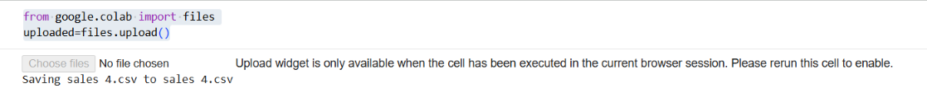
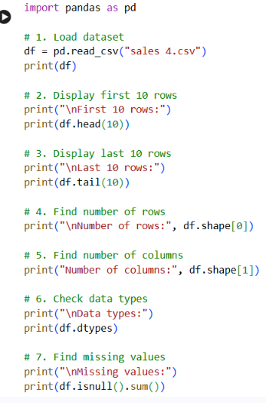
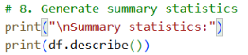
Output:-
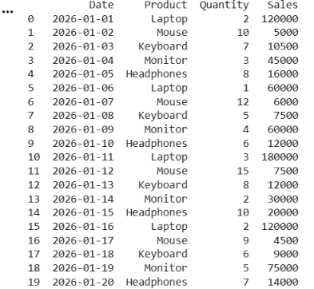

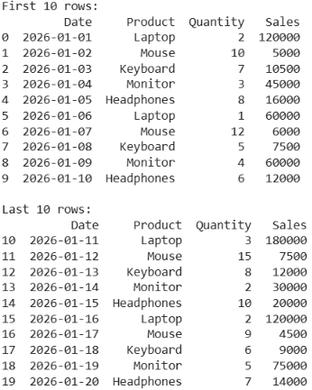

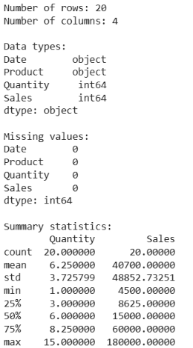

DAY 6 — Data Cleaning
Task: Learn how to clean dirty data.
Data cleaning means finding and correcting missing, duplicate, incorrect, inconsistent, or abnormal data.

1. Identify Missing Values
Theory: Missing values are empty or unavailable values in a dataset.
Program:
import pandas as pd

df = pd.read_csv("Dirtydataset6.csv")

print(df.isnull().sum())
Output:
Name 0
Age 1
City 1
Salary 2
dtype: int64
isnull() identifies missing values.

2. Count Duplicates
Theory: Duplicate rows are repeated records in a dataset.
Program:
print("Duplicate rows:", df.duplicated().sum())
Output:
Duplicate rows: 2
duplicated() identifies duplicate rows.

3. Fix Data Types
Theory: Data should have the correct data type. For example, Age should be numeric.
Program:
df["Age"] = pd.to_numeric(df["Age"], errors="coerce")

print(df.dtypes)
errors="coerce" converts invalid values such as "abc" or "twenty-one" into NaN.

4. Standardize Text
Theory: Inconsistent text means the same value is written in different formats, such as Pune, pune, and PUNE.
Program:
df["Name"] = df["Name"].str.strip().str.title()
df["City"] = df["City"].str.strip().str.title()

print(df)
For example:
pune
PUNE
Pune
becomes:
Pune
Pune
Pune

5. Remove / Handle Duplicates
Theory: Duplicate records can affect analysis, so unnecessary duplicates should be removed.
Program:
df = df.drop_duplicates()

print("Duplicates after cleaning:", df.duplicated().sum())
Output:
Duplicates after cleaning: 0

6. Handle Missing Values
Theory: Missing values can be removed or replaced with suitable values.
For numeric Age:
df["Age"] = df["Age"].fillna(df["Age"].mean())
For Salary:
df["Salary"] = df["Salary"].fillna(df["Salary"].mean())
For City:
df["City"] = df["City"].fillna("Unknown")

7. Identify Abnormal Values
Theory: Abnormal values are values that are not logically valid, such as a negative age.
Program:
print(df[df["Age"] < 0])
If negative age is found, replace it with missing:
df.loc[df["Age"] < 0, "Age"] = None
Then fill it:
df["Age"] = df["Age"].fillna(df["Age"].mean())

What they have to do
Take a dirty dataset and :- Dirtydataset6.
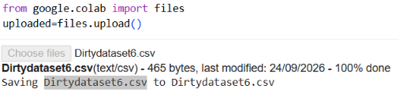

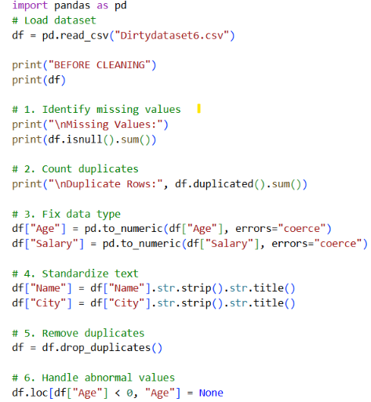

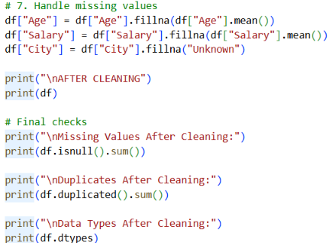

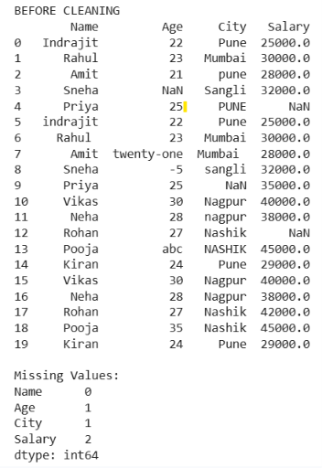
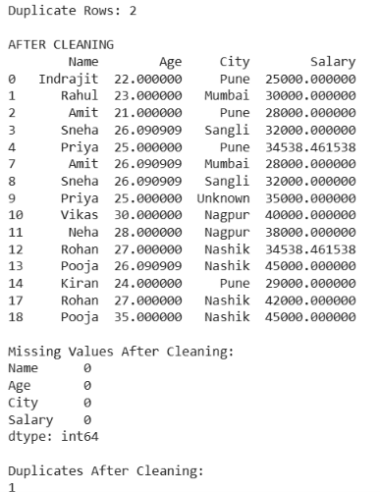

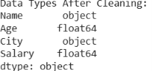

DAY 7 — SQL Fundamentals

1. Database
Theory:
A database is used to store and manage data in an organized way.
Syntax:
CREATE DATABASE database_name;
USE database_name;
Practical Query:
CREATE DATABASE shop_db;
USE shop_db;

2. Table
Theory:
A table stores data in the form of rows and columns.
Syntax:
CREATE TABLE table_name (
column1 datatype,
column2 datatype
);
Practical Query:
CREATE TABLE customers (
customer_id INT,
customer_name VARCHAR(50),
city VARCHAR(50)
);

3. Row
Theory:
A row is one complete record in a table.
Example:
1 | Rahul | Pune
This is one customer record.
Practical Query:
INSERT INTO customers
VALUES (1, 'Rahul', 'Pune');

4. Column
Theory:
A column stores one specific type of information.
Example:
customer_id
customer_name
city
Query:
SELECT customer_name
FROM customers;
This selects the customer_name column.

5. Primary Key
Theory:
A Primary Key uniquely identifies each record. Duplicate and NULL values are not allowed.
Syntax:
column_name INT PRIMARY KEY
Example:
CREATE TABLE customers (
customer_id INT PRIMARY KEY,
customer_name VARCHAR(50),
city VARCHAR(50)
);
Here, customer_id uniquely identifies each customer.

6. Foreign Key
Theory:
A Foreign Key connects two related tables.
Syntax:
FOREIGN KEY (column_name)
REFERENCES table_name(column_name)
Example:
CREATE TABLE orders (
order_id INT PRIMARY KEY,
customer_id INT,
order_amount INT,
FOREIGN KEY (customer_id)
REFERENCES customers(customer_id)
);
Here, customer_id connects orders with customers.

7. SELECT
Theory:
SELECT is used to retrieve data from a table.
Syntax:
SELECT column_name
FROM table_name;
Practical Query:
SELECT *
FROM customers;
Example:
Displays all customers.
To select specific columns:
SELECT customer_name, city
FROM customers;

8. WHERE
Theory:
WHERE filters records according to a condition.
Syntax:
SELECT *
FROM table_name
WHERE condition;
Practical Query:
SELECT *
FROM customers
WHERE city = 'Pune';
Example:
Finds only customers from Pune.
Another internship example:
SELECT *
FROM orders
WHERE order_amount > 5000;
This finds orders above ₹5,000.

9. ORDER BY
Theory:
ORDER BY is used to sort data.
ASC = Low → High
DESC = High → Low
Syntax:
SELECT *
FROM table_name
ORDER BY column_name DESC;
Practical Query:
SELECT *
FROM products
ORDER BY price DESC;
Example:
Shows the most expensive products first.

10. GROUP BY
Theory:
GROUP BY groups similar records and is commonly used with SUM(), COUNT(), and AVG().
Syntax:
SELECT column_name, SUM(column_name)
FROM table_name
GROUP BY column_name;
Practical Query:
SELECT customer_id, SUM(order_amount) AS total_sales
FROM orders
GROUP BY customer_id;
Example:
Calculates total sales for each customer.

11. HAVING
Theory:
HAVING filters the results after GROUP BY.
Syntax:
SELECT column_name, SUM(column_name)
FROM table_name
GROUP BY column_name
HAVING condition;
Practical Query:
SELECT customer_id, SUM(order_amount) AS total_sales
FROM orders
GROUP BY customer_id
HAVING SUM(order_amount) > 5000;
Example:
Finds customers whose total sales are above ₹5,000.
Remember:
WHERE → Filter rows
HAVING → Filter groups

12. DISTINCT
Theory:
DISTINCT is used to get only unique values and remove duplicates.
Syntax:
SELECT DISTINCT column_name
FROM table_name;
Practical Query:
SELECT DISTINCT city
FROM customers;
Example:
If Pune appears 5 times, it will appear only once in the result.

13. CASE
Theory:
CASE is used to apply conditions and create categories. It works like IF-ELSE.
Syntax:
CASE
WHEN condition THEN result
ELSE result
END
Practical Query:
SELECT
order_id,
order_amount,
CASE
WHEN order_amount >= 50000 THEN 'High'
WHEN order_amount >= 10000 THEN 'Medium'
ELSE 'Low'
END AS category
FROM orders;
Example:
55000 → High
25000 → Medium
5000 → Low

What They Have to Do — Answer
1. Create a Database
Create a database for the SQL practical task.
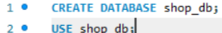
2. Create Three Tables
Create the following tables
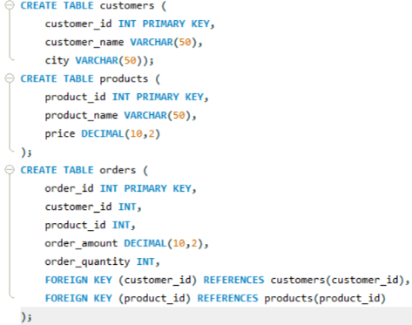
3. Insert Sample Data
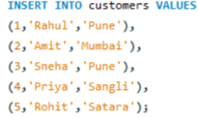
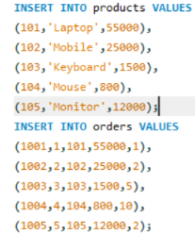
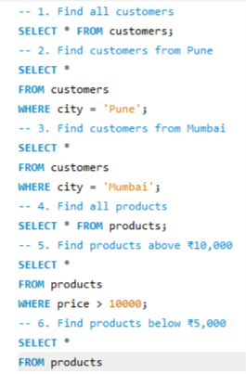
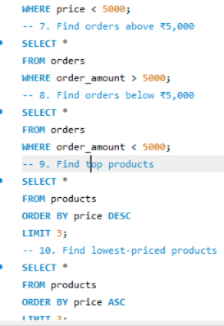
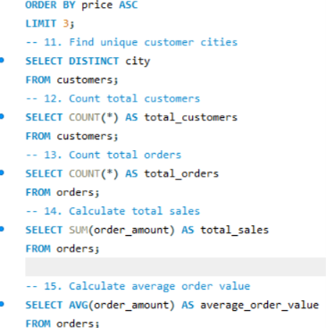
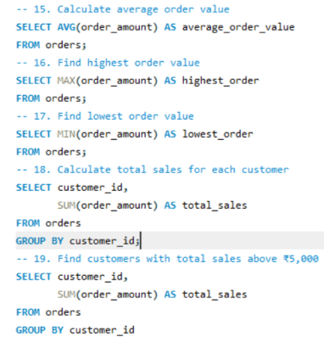
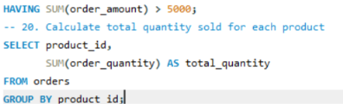
Why?
Ans:-SQL is one of the most important skills for Data Analysts because it helps them access, filter, manage, and analyze data from databases. It is used to find useful information, calculate results, and support data-driven decisions.
File link:-D:\all important\techosigni\mysql\task7.sql

DAY 8 — Advanced SQL
1. JOIN
Theory
JOIN is used to combine data from two or more tables using a related column.
For example, customers and orders can be joined using customer_id.
Syntax
SELECT columns
FROM table1
JOIN table2
ON table1.column = table2.column;
Example
SELECT c.customer_name, o.order_amount
FROM customers c
JOIN orders o
ON c.customer_id = o.customer_id;
This shows the customer name with their order amount.

2. INNER JOIN
Theory
INNER JOIN returns only the records that have a matching value in both tables.
Syntax
SELECT columns
FROM table1
INNER JOIN table2
ON table1.column = table2.column;
Example
SELECT c.customer_name, o.order_amount
FROM customers c
INNER JOIN orders o
ON c.customer_id = o.customer_id;
Only customers who have orders will be displayed.

3. LEFT JOIN
Theory
LEFT JOIN returns all records from the left table and matching records from the right table. If there is no match, NULL is returned.
Syntax
SELECT columns
FROM table1
LEFT JOIN table2
ON table1.column = table2.column;
Example
SELECT c.customer_name, o.order_amount
FROM customers c
LEFT JOIN orders o
ON c.customer_id = o.customer_id;
This shows all customers, including customers who have not placed an order.

4. Subquery
Theory
A Subquery is a query written inside another SQL query.
It is useful when the result of one query is needed by another query.
Syntax
SELECT *
FROM table_name
WHERE column_name > (
SELECT value
FROM table_name
);
Example
Find products having a price greater than the average price:
SELECT *
FROM products
WHERE price > (
SELECT AVG(price)
FROM products
);

5. CTE
Theory
CTE (Common Table Expression) creates a temporary result that can be used by the main query.
It makes complex queries easier to read and manage.
Syntax
WITH cte_name AS (
SELECT ...
)
SELECT *
FROM cte_name;
Example
WITH sales AS (
SELECT customer_id, SUM(order_amount) AS total_sales
FROM orders
GROUP BY customer_id
)
SELECT *
FROM sales
WHERE total_sales > 5000;
This first calculates customer-wise sales and then finds customers with sales above ₹5,000.

6. Window Functions
Theory
Window Functions perform calculations across related rows without combining them into a single row.
They are commonly used for:
- Ranking
- Comparing rows
- Finding previous/next values
- Running totals
Syntax
function_name()
OVER (
PARTITION BY column
ORDER BY column
);
Example
SELECT customer_id,
order_amount,
RANK() OVER (ORDER BY order_amount DESC) AS ranking
FROM orders;
This ranks orders from highest to lowest amount.

7. ROW_NUMBER()
Theory
ROW_NUMBER() assigns a unique sequential number to each row.
Syntax
ROW_NUMBER() OVER (
ORDER BY column_name DESC
)
Example
SELECT customer_id,
order_amount,
ROW_NUMBER() OVER (ORDER BY order_amount DESC) AS row_num
FROM orders;
Result may look like:
order_amount row_num
55000 1
25000 2
12000 3

8. RANK()
Theory
RANK() gives the same rank to equal values. After a tie, it skips the next rank.
Syntax
RANK() OVER (
ORDER BY column_name DESC
)
Example
SELECT employee_name,
salary,
RANK() OVER (ORDER BY salary DESC) AS salary_rank
FROM employees;
If salaries are:
50000 → 1
50000 → 1
40000 → 3

9. DENSE_RANK()
Theory
DENSE_RANK() also gives the same rank to equal values, but it does not skip ranks.
Syntax
DENSE_RANK() OVER (
ORDER BY column_name DESC
)
Example
SELECT employee_name,
salary,
DENSE_RANK() OVER (ORDER BY salary DESC) AS salary_rank
FROM employees;
If salaries are:
50000 → 1
50000 → 1
40000 → 2
Difference
RANK() → 1, 1, 3
DENSE_RANK() → 1, 1, 2

10. LAG()
Theory
LAG() returns the value from a previous row.
It is useful for comparing current data with previous data.
Syntax
LAG(column_name)
OVER (ORDER BY column_name);
Example
SELECT month,
revenue,
LAG(revenue) OVER (ORDER BY month) AS previous_revenue
FROM monthly_sales;
This shows the previous month's revenue.

11. LEAD()
Theory
LEAD() returns the value from the next row.
Syntax
LEAD(column_name)
OVER (ORDER BY column_name);
Example
SELECT month,
revenue,
LEAD(revenue) OVER (ORDER BY month) AS next_revenue
FROM monthly_sales;
This shows the next month's revenue.
What they have to do
Solve:
1. Top 3 customers.
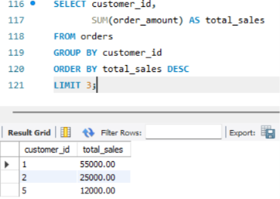
2. Top 3 products per category
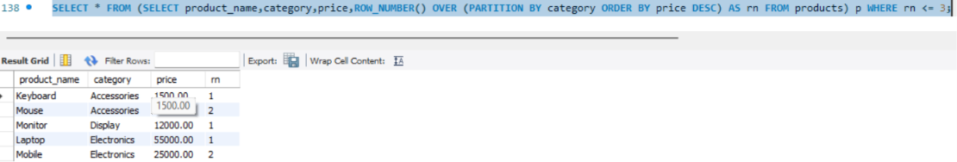
3. Customer Ranking.
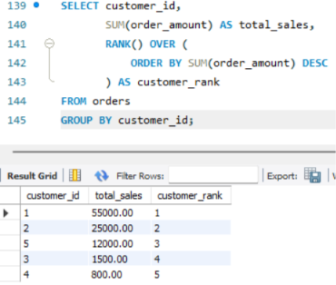
4. Monthly Revenue.
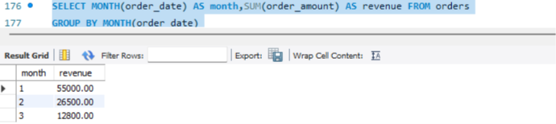
5. Previous Month's Revenue.
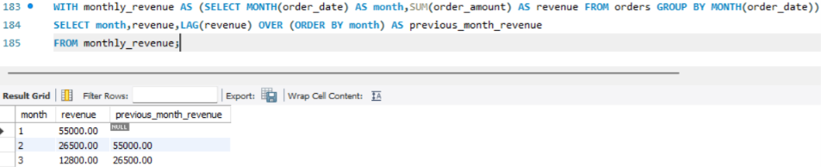
6. Month-over-Month Growth.
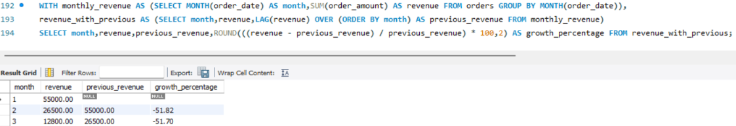
7. Employee salary ranking.
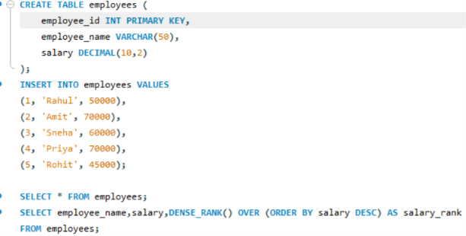

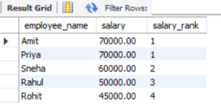

DAY 9 — STATISTICS
Date:-21/09/2026
Task Description:- Here is the complete Day 9 assignment in the proper format, including the Task Description, Objectives, Dataset, Code, Results, and Explanation. The assignment source asks you to learn the listed statistical concepts, calculate them using a dataset, and explain what each value means and why it is useful.
*Import Library
import pandas as pd
Description:
Pandas is used for creating and analyzing the dataset.
*Create Dataset
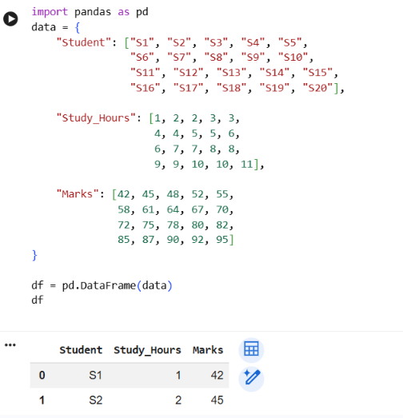

- Mean
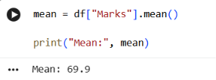
Description
Mean is the average value of the marks.
Why: It tells us the overall average performance of the students.
2.Median
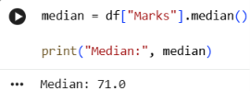
Description
Median is the middle value when the data is arranged in ascending order.
Why: It represents the central position of the dataset.
3.Mode
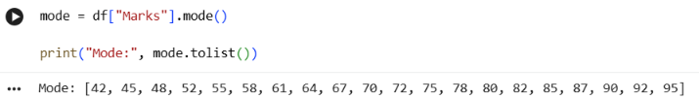
Description
Mode is the value that occurs most frequently.
Here, every mark occurs only once, so there is no single mode.
Why: Mode is useful for finding the most common value.
4. Range
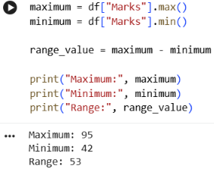
Description
Range is the difference between the highest and lowest values.
Why: It tells us the overall spread of the marks.
5. Variance
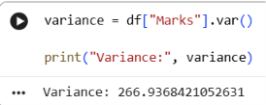
Description
Variance measures how much the marks differ from the mean.
Why: It helps measure the variability of the data.
6. Standard Deviation
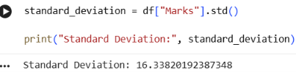
Description
Standard deviation measures how far values generally spread from the mean.
Why: It shows the typical variation in marks.
7. Percentile
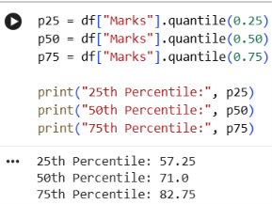
Description
A percentile shows the position of a value relative to the rest of the dataset.
Why: It helps understand how observations are distributed.
8. Quartile
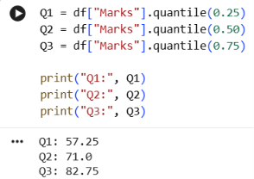
Description
Quartiles divide the ordered dataset into four parts.
- Q1: First quartile
- Q2: Second quartile / Median
- Q3: Third quartile
Why: Quartiles help understand the distribution of data
9. IQR
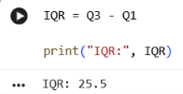
Description
IQR means Interquartile Range.
Formula
IQR = Q3 - Q1
Why: IQR measures the spread of the middle 50% of the data.
10. Correlation
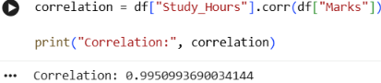
Description
Correlation measures the strength and direction of a linear relationship between two variables.
Here, the correlation is very close to +1, indicating a very strong positive linear association between study hours and marks in this dataset.
Why: It helps us understand whether two variables are related.
11. Covariance
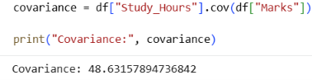
Description
Covariance tells us whether two variables tend to move together.
Here, covariance is positive, meaning study hours and marks generally increase together.
Why: It helps identify the direction in which two variables move.

Final result:-
Statistic | Result
Mean | 69.90
Median | 71.00
Mode | Mode: [42, 45, 48, 52, 55, 58, 61, 64, 67, 70, 72, 75, 78, 80, 82, 85, 87, 90, 92, 95]
Range | 53.00
Variance | 266.94
Standard Deviation | 16.34
25th Percentile | 57.25
50th Percentile | 71.00
75th Percentile | 82.75
Q1 | 57.25
Q2 | 71.00
Q3 | 82.75
IQR | 25.50
Correlation | 0.9951
Covariance | 48.63

Overall Conclusion
The Student Performance dataset was analyzed using different statistical measures.
The mean of 69.90 represents the average marks, while the median of 71 represents the middle value. The range, variance, and standard deviation describe the spread of the marks.
The quartiles and IQR help us understand the distribution of the middle portion of the data. Correlation and covariance show the relationship between study hours and marks.
In this dataset, the correlation of 0.9951 indicates a very strong positive linear association: students with more study hours tend to have higher marks. This is an association observed in this dataset, not proof that study hours alone cause the higher marks.
Assignment completed: Dataset → Calculation → Interpretation → Why each statistic is useful.

DAY 10 — PROBABILITY
Date:-23/09/2026
Task basis: Learn probability, conditional probability, independent events, dependent events, Bayes theorem, normal distribution and binomial distribution; solve at least 15 problems and implement 5 using Python.

1. Probability
Description: Probability tells us how likely an event is to happen. Its value is between 0 and 1.
Formula: P(E) = Favorable outcomes / Total outcomes.
Example: A coin is tossed once. Outcomes are Head and Tail. P(Head) = 1/2 = 0.5.
Python:
favorable = 1;
total = 2;
probability = favorable / total;
print(probability)
Output: 0.5

2. Conditional Probability
Description: Conditional probability finds the probability of an event when another event is already known to have occurred.
Formula: P(A|B) = P(A and B) / P(B).
Example: If 12 boys are in a class and 5 boys know Python, P(Python|Boy) = 5/12 = 0.4167.
Python: boys = 12; boys_python = 5;
print(boys_python / boys)
Output: 0.4166666667

3. Independent Events
Description: Independent events do not affect each other.
Formula: P(A and B) = P(A) × P(B).
Example: Toss a coin and roll a die. P(Head and 6) = 1/2 × 1/6 = 1/12 = 0.0833.
Python: print((1/2) * (1/6))
Output: 0.0833333333

4. Dependent Events
Description: Dependent events affect each other. The probability changes after the first event.
Formula: P(A and B) = P(A) × P(B|A).
Example: A bag has 5 red and 3 blue balls. Two red balls are selected without replacement.
P(first red) = 5/8; P(second red | first red) = 4/7.
Therefore P(two red) = 5/8 × 4/7 = 0.3571.
Python: print((5/8) * (4/7))
Output: 0.3571428571

5. Bayes Theorem
Description: Bayes theorem calculates a conditional probability using prior information.
Formula: P(A|B) = P(B|A)P(A) / P(B).
Example: Disease prevalence = 1%, test sensitivity = 90%, false positive rate = 5%.
P(+) = 0.90×0.01 + 0.05×0.99 = 0.0585.
P(Disease|+) = 0.90×0.01 / 0.0585 = 0.1538, or 15.38%.
Python:
p_disease = 0.01
p_positive_disease = 0.90
p_positive_no_disease = 0.05
p_no_disease = 1 - p_disease
p_positive = p_positive_disease*p_disease + p_positive_no_disease*p_no_disease
result = p_positive_disease*p_disease/p_positive
print(result)
Output: 0.1538461538

6. Normal Distribution
Description: Normal distribution is a continuous, bell-shaped probability distribution. Mean represents the center and standard deviation represents spread.
Z-score formula: Z = (X - mean) / standard deviation.
Example: Mean = 70, standard deviation = 10, mark = 80.
Z = (80-70)/10 = 1.
Python: x=80; mean=70; std=10; print((x-mean)/std)
Output: 1.0

7. Binomial Distribution
Description: Binomial distribution is used for a fixed number of independent trials with two outcomes and the same probability of success.
Formula: P(X=k) = C(n,k) p^k (1-p)^(n-k).
Example: Toss a coin 5 times and find probability of exactly 3 Heads.
P(X=3) = C(5,3)(0.5)^3(0.5)^2 = 0.3125.
Python:
from math import comb
n=5; k=3; p=0.5
probability = comb(n,k)*(p**k)*((1-p)**(n-k))
print(probability)
Output: 0.3125

8. 15 Probability Problems — Step by Step

1. Coin
A coin is tossed once. P(Head) = 1/2 = 0.5.
Answer: 0.5

2. Dice
A die is rolled. P(4) = 1/6.
Answer: 0.1667

3. Even Number
Even outcomes are 2, 4, 6. P(Even) = 3/6 = 0.5.
Answer: 0.5

4. Odd Number
Odd outcomes are 1, 3, 5. P(Odd) = 3/6 = 0.5.
Answer: 0.5

5. Red Ball
A bag has 5 red and 3 blue balls. P(Red) = 5/8.
Answer: 0.625

6. Blue Ball
For the same bag, P(Blue) = 3/8.
Answer: 0.375

7. Two Heads
Two coin tosses have HH, HT, TH, TT. Only HH is favorable: 1/4.
Answer: 0.25

8. At Least One Head
For two tosses, HH, HT, TH contain at least one Head: 3/4.
Answer: 0.75

9. Sum of 7
Two dice have 36 outcomes. Six outcomes give sum 7: 1+6, 2+5, 3+4, 4+3, 5+2, 6+1. P=6/36.
Answer: 0.1667

10. Ace
A standard deck has 4 Aces among 52 cards. P(Ace)=4/52=1/13.
Answer: 0.0769

11. King
A standard deck has 4 Kings among 52 cards. P(King)=4/52.
Answer: 0.0769

12. Independent Events
Coin Head and die 6: P = 1/2 × 1/6 = 1/12.
Answer: 0.0833

13. Dependent Events
Two red balls without replacement: P = 5/8 × 4/7.
Answer: 0.3571

14. Binomial
Five coin tosses, exactly 3 Heads: P = C(5,3)(0.5)^3(0.5)^2.
Answer: 0.3125

15. Normal Distribution
Mean=70, SD=10, X=80. Z=(80-70)/10.
Answer: Z-score = 1

9. Five Python Implementations

Problem 1 — Coin Probability
favorable = 1
total = 2
probability = favorable / total
print("Probability of Head:", probability)

Problem 2 — Dice Probability
favorable = 3
total = 6
probability = favorable / total
print("Probability of Even Number:", probability)

Problem 3 — Dependent Events
first_red = 5 / 8
second_red = 4 / 7
probability = first_red * second_red
print("Probability of two red balls:", probability)

Problem 4 — Bayes Theorem
p_disease = 0.01
p_positive_disease = 0.90
p_positive_no_disease = 0.05
p_no_disease = 1 - p_disease
p_positive = p_positive_disease*p_disease + p_positive_no_disease*p_no_disease
result = p_positive_disease*p_disease/p_positive
print("Probability:", result)

Problem 5 — Binomial Distribution
from math import comb
n = 5
k = 3
p = 0.5
probability = comb(n,k) * (p**k) * ((1-p)**(n-k))
print("Probability of exactly 3 Heads:", probability)

10. Conclusion
Probability is an important mathematical foundation for Data Science and Machine Learning. It helps describe uncertainty, conditional relationships, distributions and prediction.

